PIERBURG Sekundärluft-System SLP Service Information Si0012 Abgas SLS Ventil , SLV ,

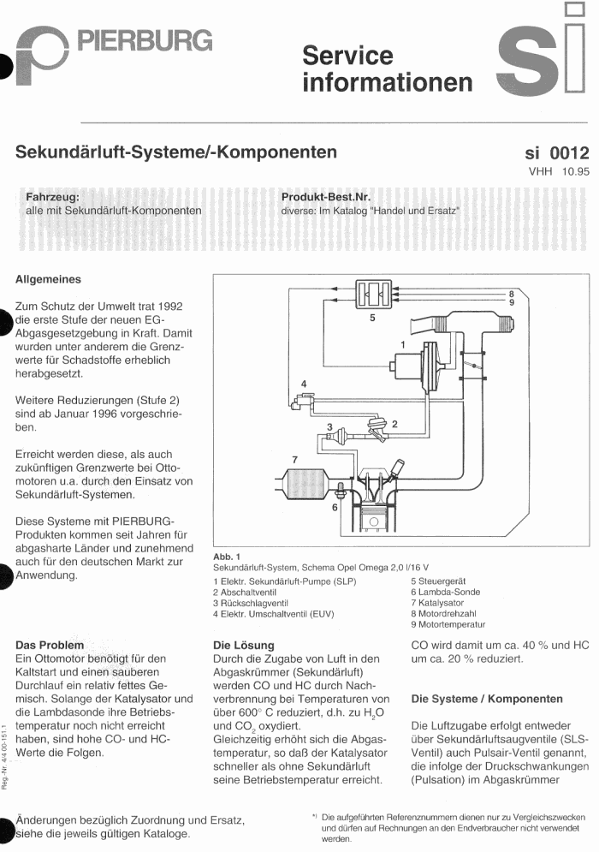
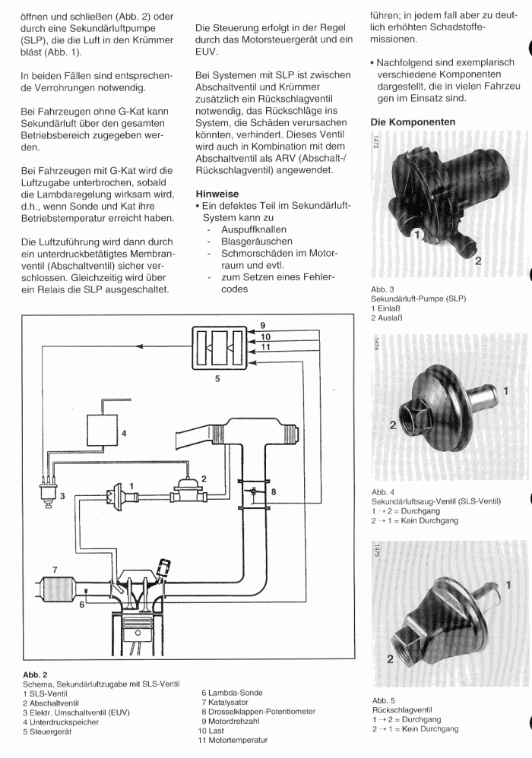
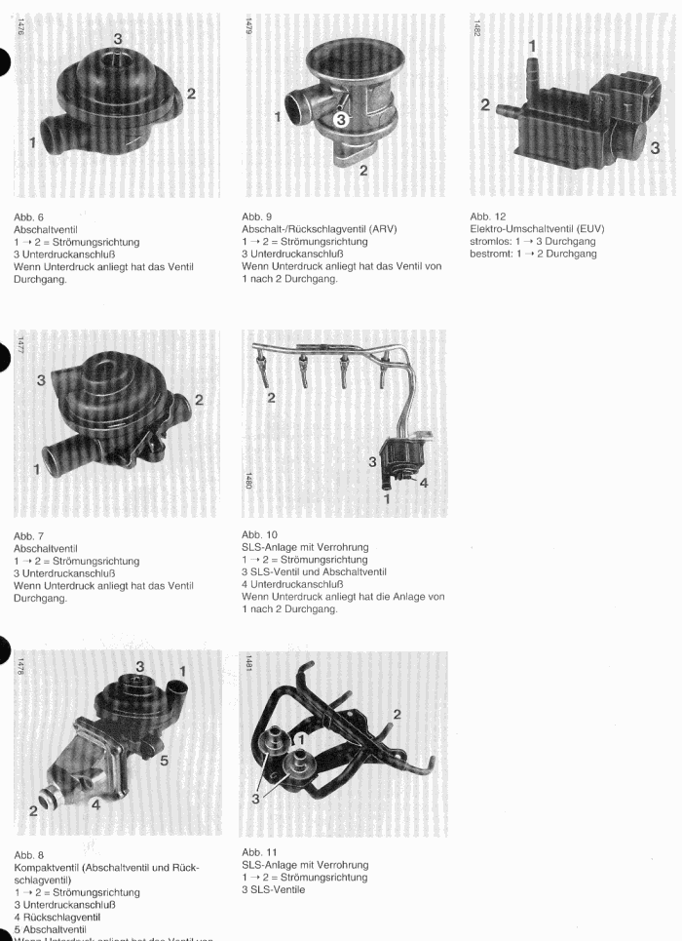
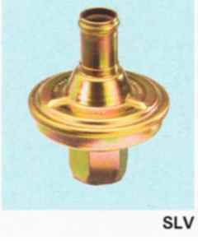 7.21695.97.0
Si0026 Si0059 Pi0026 Si0083 Si0102
7.22778.16.0 7.28238.27.0 7.21846.58.0 7.22778.17.0 7.22748.18.0 7.28238.56.0 7.21695.47.0 = 7.21695.97.0 7.28238.58.0 7.28238.57.0 7.21695.97 7.28238.55.0

